ANALYSIS ON FOREST FIRE 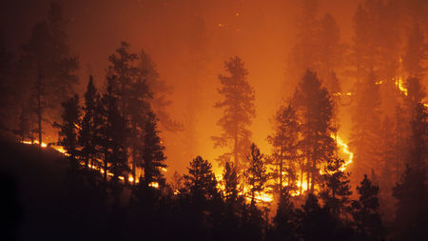

THE HOPLITES

Surendra,shazia,Chandana

1.INTRODUCTION:

|  |
| --- |
|  |

Wildfires are a natural occurrance and serve important ecosystem functions. Forest landscapes are dynamic and change in response to variations in climate and to disturbances from natural sources, such as fires caused by lightning strikes. Many tree species have evolved to take advantage of fire, and periodic burns can contribute to overall forest health. Fires typically move through burning lower branches and clearing dead wood from the forest floor which kick-starts regeneration by providing ideal growing conditions. It also improves floor habitat for many species that prefer relatively open spaces.

After a fire burns down a swath of woodland, a sequence of ecological responses, or succession, begins. Amid the charred forest remains, a flourishing of pioneer species begins, usually quick-growing grasses and weeds, followed by a steady advance of slower-growing, taller species of plants. The first trees to emerge are often small pines, followed by larger pines and finally by hardwood species, including oak and hickory.

Forest fire causes imbalances in nature and endangers biodiversity by reducing faunal and floral wealth. Traditional methods of fire prevention are not proving effective and it is now essential to raise public awareness on the matter, particularly among those people who live close to or in forested areas.

1.a OBJECTIVES OF RESEARCH:

• To protect the wildlife and natural resources

• To protect the environment from green house gases

• Large Fire Management

• Resource Acquisation and strategic Deployment.

1.b PROBLEM OF STATEMENT:

Our project is to determine the area burned and to determine the conditions and situations of the forest.

1.c INDUSTRY PROFILE:

This project is used mainly to people of fire department and forest department.

2.REVIEW OF LITERATURE:

• Prediction of Forest Fire Area Better Helps in forest fire management.

• Management Of Active Fires On the Basis of Behavior Prediction.

• A Direct Forest Fire Management is Control Of Each Fire Spread and development on the basis of it’s behavior prediction

3.DATA ANALYSIS:

1. Spatial information:

* X - x-axis spatial coordinate within the Montesinho park map.
* Y - y-axis spatial coordinate within the Montesinho park map.

2.Temporal information:

* month - month of the year: 'jan' to 'dec'.
* day - day of the week: 'mon' to 'sun'.

3.FWI (forest Fire Weather Index):

* FFMC - FFMC index from the FWI system.
* DMC - DMC index from the FWI system.
* DC - DC index from the FWI system.
* ISI - ISI index from the FWI system.

4.Meteorological information:

* Temp - temperature in Celsius.
* RH - relative humidity.
* Wind - wind speed.
* Rain - outside rain.

5.area - the burned area of the forest.

FOREST WEATHER INDEX:

The F Weather Index (FWI) is a numeric rating of fire intensity. It combines the Initial Spread Index and the Buildup Index. It is suitable as a general index of fire danger throughout the forested areas

**Forest Fire Weather Index (FWI) System** consists of six components that account for the effects of fuel moisture and wind on fire behavior.

The first three components, the fuel moisture codes, are numeric ratings of the moisture content of litter and other fine fuels, the average moisture content of loosely compacted organic layers of moderate depth, and the average moisture content of deep, compact organic layers.

The remaining three components are fire behavior indices, which represent the rate of fire spread, the fuel available for combustion, and the frontal fire intensity; their values rise as the fire danger increases.

### Fine Fuel Moisture Code:

The Fine Fuel Moisture Code (FFMC) is a numeric rating of the moisture content of litter and other cured fine fuels. This code is an indicator of the relative ease of ignition and the flammability of fine fuel.

### Duff Moisture Code:

The Duff Moisture Code (DMC) is a numeric rating of the average moisture content of loosely compacted organic layers of moderate depth. This code gives an indication of fuel consumption in moderate duff layers and medium-size woody material.

### Drought Code:

The Drought Code (DC) is a numeric rating of the average moisture content of deep, compact organic layers. This code is a useful indicator of seasonal drought effects on forest fuels and the amount of smoldering in deep duff layers and large logs.

### Initial Spread Index:

The Initial Spread Index (ISI) is a numeric rating of the expected rate of fire spread. It combines the effects of wind and the FFMC on rate of spread without the influence of variable quantities of fuel

**Build -Up Index :**

This index shows the **amount of fuel available for combustion**, indicating **how the fire will develop after initial spread**. It is calculated from the Duff Moisture Code and the Drought Code.

The BUI scale starts at zero and is ***open-ended***. A rating above 40 is high, above 60 is extreme.

Relative Humidity:

Relative humidity is an expression of the amount of moisture in the air compared to the total amount the air is capable of holding at that temperature and pressure. Relative humidity (along with temperature) controls fuel moisture content up to about 32 percent. Liquid moisture such as rain or dew must contact a fuel for moisture content to rise above 32 percent, and the increase depends upon duration as well as the amount of precipitation.

4.METHODOLOGY:

4.1 Exploratory data analysis:

Description of elements:

ff.describe():

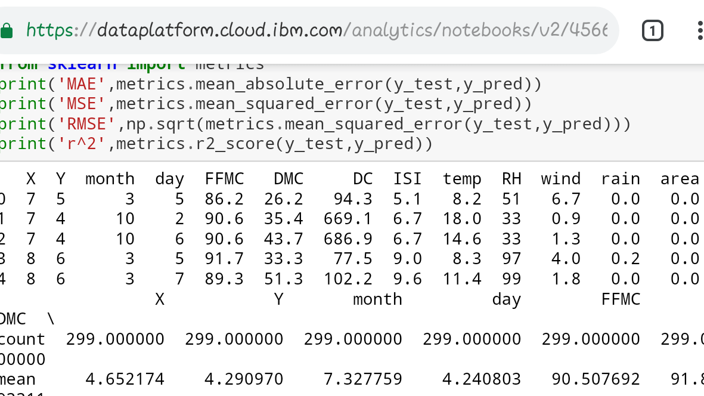

Here we detect outliers for the variables and replace them with the median of their respective columns using the following code snippet.

Median=df.x.median() df['X']=df['X'].mask((df['X']<maxvalue),median)

4.1.1 figures and tables:

The Co-relation between the attributes can be given as

ff.corr()



4.2 Statistical Data and Data Visualization:

X - 1 to 9

Y - 2 to 9.

month - 'jan' to 'dec'

day - 'mon' to 'sun'

FFMC - 18.7 to 96.20

DMC - 1.1 to 291.3

DC - 7.9 to 860.6

ISI - 0.0 to 56.10

temp - 2.2 to 33.30

RH - relative humidity in %: 15.0 to 100

wind - wind speed in km/h: 0.40 to 9.40

rain - outside rain in mm/m2 : 0.0 to 6.4

area - the burned area of the forest (in ha): 0.00 to 1090.8

|  |  |  |  |  |  |  |  |  |  |  |  |  |
| --- | --- | --- | --- | --- | --- | --- | --- | --- | --- | --- | --- | --- |
| X | Y | month | day | FFMC | DMC | DC | ISI | temp | RH | wind | X | Y |
| 7 | 5 | mar | fri | 86.2 | 26.2 | 94.3 | 5.1 | 8.2 | 51 | 6.7 | 3 | 1 |
| 7 | 4 | oct | tue | 90.6 | 35.4 | 669.1 | 6.7 | 18 | 33 | 0.9 | 1 | -2 |
| 7 | 4 | oct | sat | 90.6 | 43.7 | 686.9 | 6.7 | 14.6 | 33 | 1.3 | 1 | -2 |
| 8 | 6 | mar | fri | 91.7 | 33.3 | 77.5 | 9 | 8.3 | 97 | 4 | 4 | 2 |
| 8 | 6 | mar | sun | 89.3 | 51.3 | 102.2 | 9.6 | 11.4 | 99 | 1.8 | 4 | 2 |
| 8 | 6 | aug | sun | 92.3 | 85.3 | 488 | 14.7 | 22.2 | 29 | 5.4 | 4 | 2 |
| 8 | 6 | aug | mon | 92.3 | 88.9 | 495.6 | 8.5 | 24.1 | 27 | 3.1 | 4 | 2 |
| 8 | 6 | aug | mon | 91.5 | 145.4 | 608.2 | 10.7 | 8 | 86 | 2.2 | 4 | 2 |
| 8 | 6 | sep | tue | 91 | 129.5 | 692.6 | 7 | 13.1 | 63 | 5.4 | 4 | 2 |
| 7 | 5 | sep | sat | 92.5 | 88 | 698.6 | 7.1 | 22.8 | 40 | 4 | 3 | 1 |
| 7 | 5 | sep | sat | 92.5 | 88 | 698.6 | 7.1 | 17.8 | 51 | 7.2 | 3 | 1 |
| 7 | 5 | sep | sat | 92.8 | 73.2 | 713 | 22.6 | 19.3 | 38 | 4 | 3 | 1 |
| 6 | 5 | aug | fri | 63.5 | 70.8 | 665.3 | 0.8 | 17 | 72 | 6.7 | 4 | 3 |
| 6 | 5 | sep | mon | 90.9 | 126.5 | 686.5 | 7 | 21.3 | 42 | 2.2 | 4 | 3 |
| 6 | 5 | sep | wed | 92.9 | 133.3 | 699.6 | 9.2 | 26.4 | 21 | 4.5 | 4 | 3 |
| 6 | 5 | sep | fri | 93.3 | 141.2 | 713.9 | 13.9 | 22.9 | 44 | 5.4 | 4 | 3 |
| 5 | 5 | mar | sat | 91.7 | 35.8 | 80.8 | 7.8 | 15.1 | 27 | 5.4 | 5 | 5 |
| 8 | 5 | oct | mon | 84.9 | 32.8 | 664.2 | 3 | 16.7 | 47 | 4.9 | 2 | -1 |
| 6 | 4 | mar | wed | 89.2 | 27.9 | 70.8 | 6.3 | 15.9 | 35 | 4 | 2 | 0 |

Histograms:

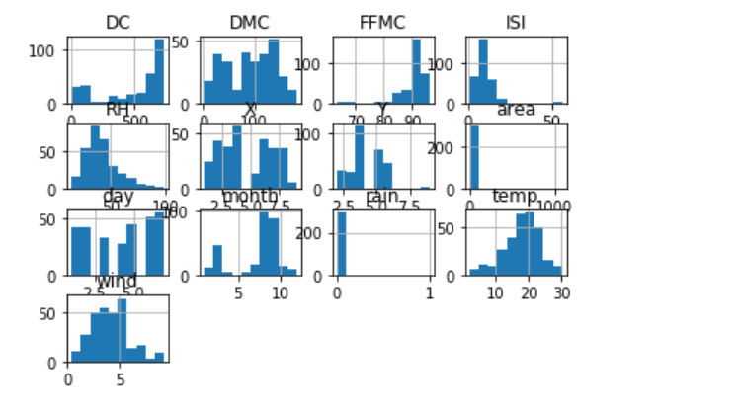

boxplots

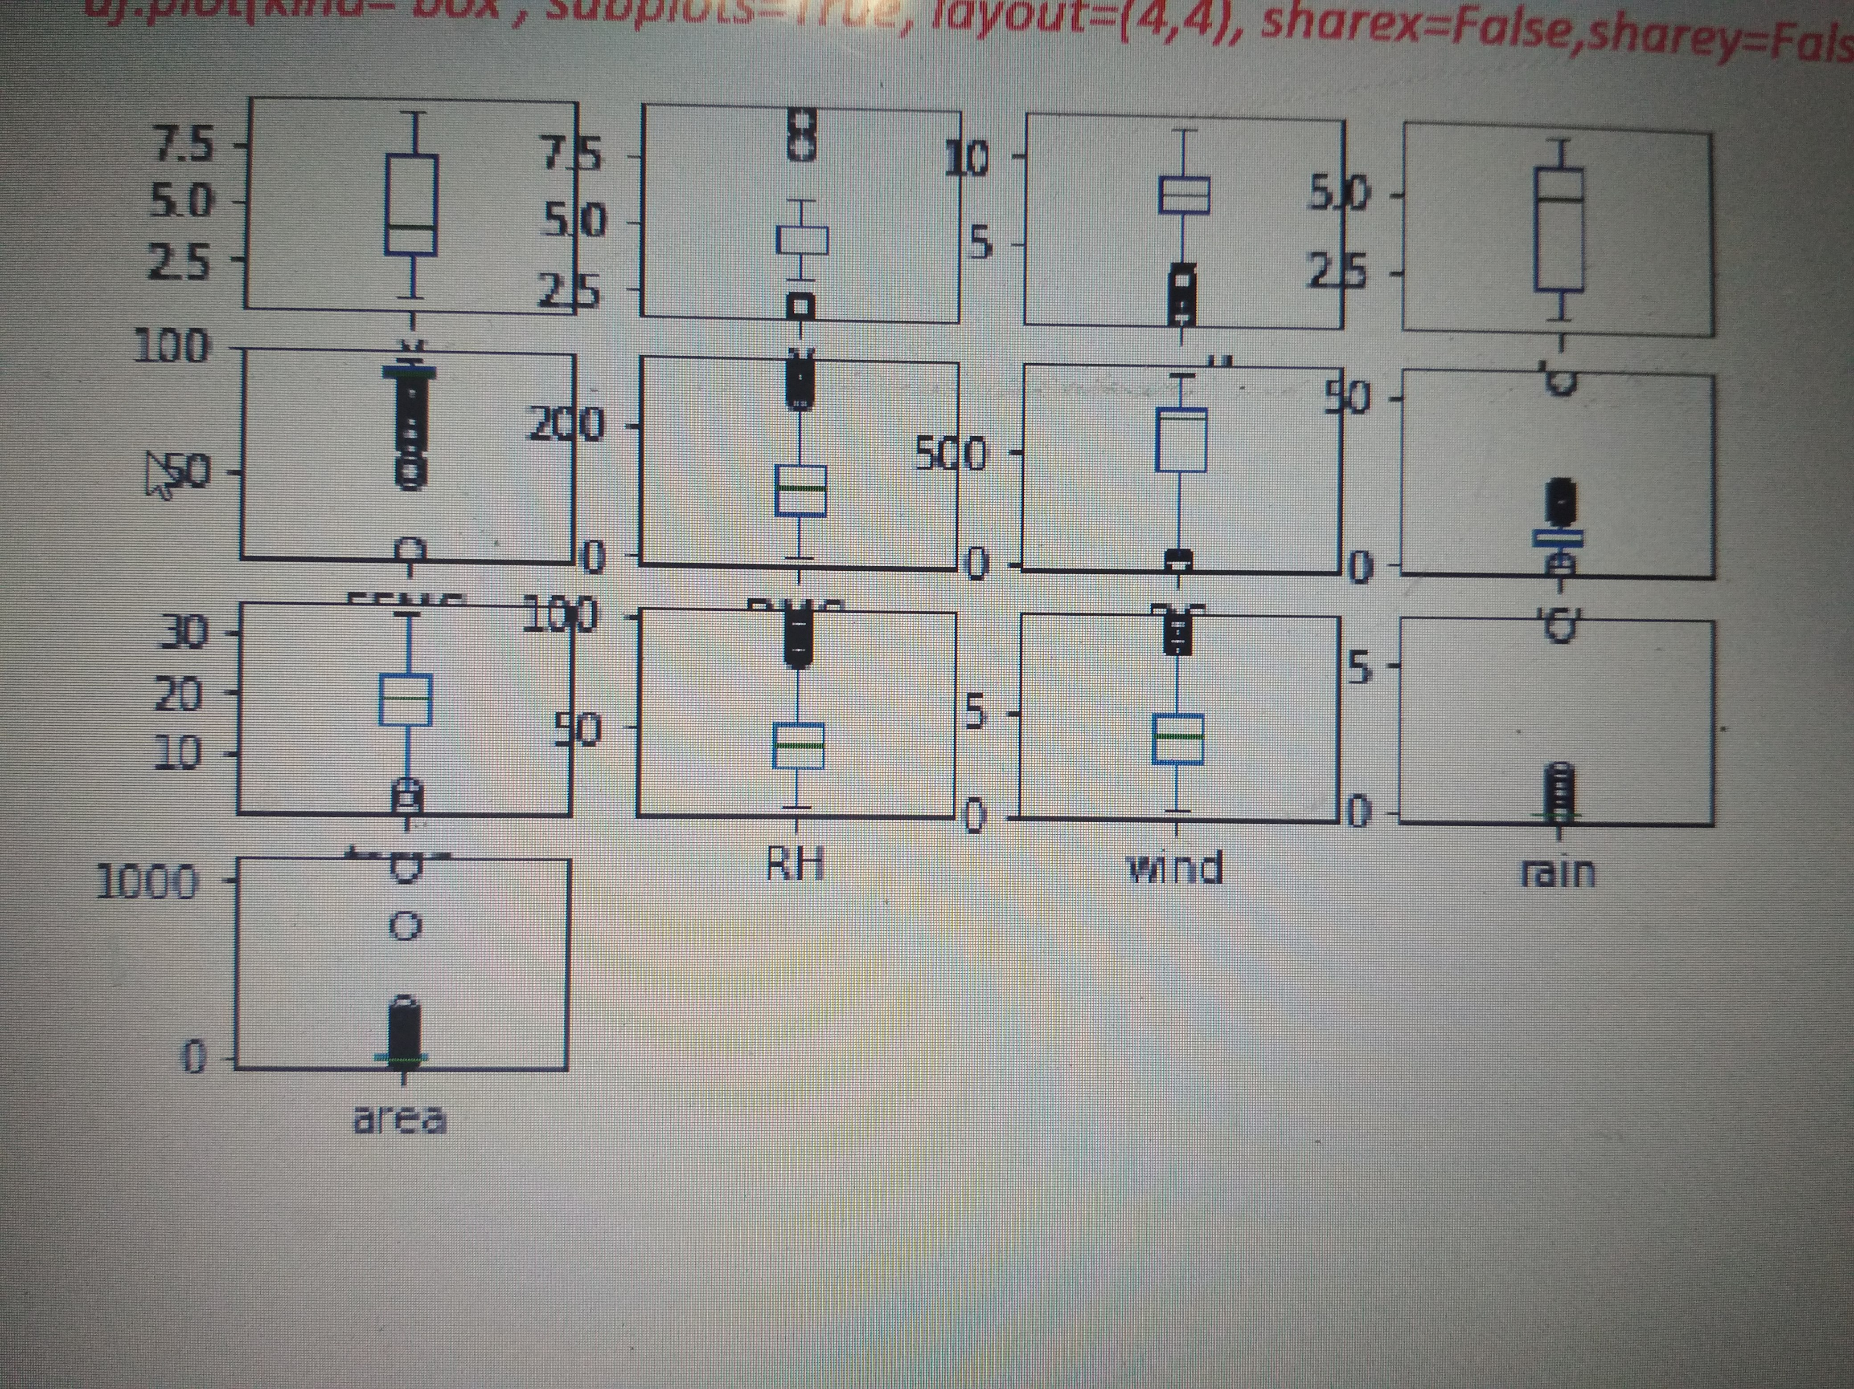

4.2 Statistical Data and Data Visualization:

X - 1 to 9

Y - 2 to 9.

month - 'jan' to 'dec'

day - 'mon' to 'sun'

FFMC - 18.7 to 96.20

DMC - 1.1 to 291.3

DC - 7.9 to 860.6

ISI - 0.0 to 56.10

temp - 2.2 to 33.30

RH - relative humidity in %: 15.0 to 100

wind - wind speed in km/h: 0.40 to 9.40

rain - outside rain in mm/m2 : 0.0 to 6.4

area - the burned area of the forest (in ha): 0.00 to 1090.8

Data Modeling Using Supervised ML Techniques:

Here we use Decision Tree Regression which best suits the predicition with an accuracy of 0.999

Decision tree regression observes features of an object and trains a model in the structure of a tree to predict data in the future to produce me0…aningful continuous output. Continuous output means that the output/result is not discrete, i.e., it is not represented just by a discrete, known set of numbers or values.

Here since we have the dependent feature area as a continuous variable this regression is very suitable.

from sklearn.tree

import DecisionTreeRegressor regressor = DecisionTreeRegressor(random_state = 0) regressor.fit(X, y)

Here we fit the dataset with decision tree regressor using the above code snippet

y_pred = regressor.predict(X_test)

Now , the predicition can be done using the above line of code.

from sklearn import metrics print('MAE',metrics.mean_absolute_error(y_test,y_pred)) print('MSE',metrics.mean_squared_error(y_test,y_pred)) print('RMSE',np.sqrt(metrics.mean_squared_error(y_test,y_pred))) print('r^2',metrics.r2_score(y_test,y_pred))

Now we have metric measures as MAE 0.12163461538461538 MSE 0.5912389423076924 RMSE 0.7689206345961151 r^2 0.9999741805536381

Findings and Suggestions:

The Large Area Of Forest Fire Burns is Mainly because of Rising Temparatures day for day . Large Forest Area Fire Issues are due to lack of rainfall . We can also include other features such as cloudiness and hemisphere of location in the dataset to predict more accurately.

Conclusion:

* Incidents of Forest Fires in size, frequency and intensity are controlled by weather variables

* Here by we conclude that we predicted the forest area that burned due to forest fire.
* We can save the forest area as well as the wild life by our project data.